Task Description for Practical Course Control and Simulation of Rocket Hopper Demonstrator
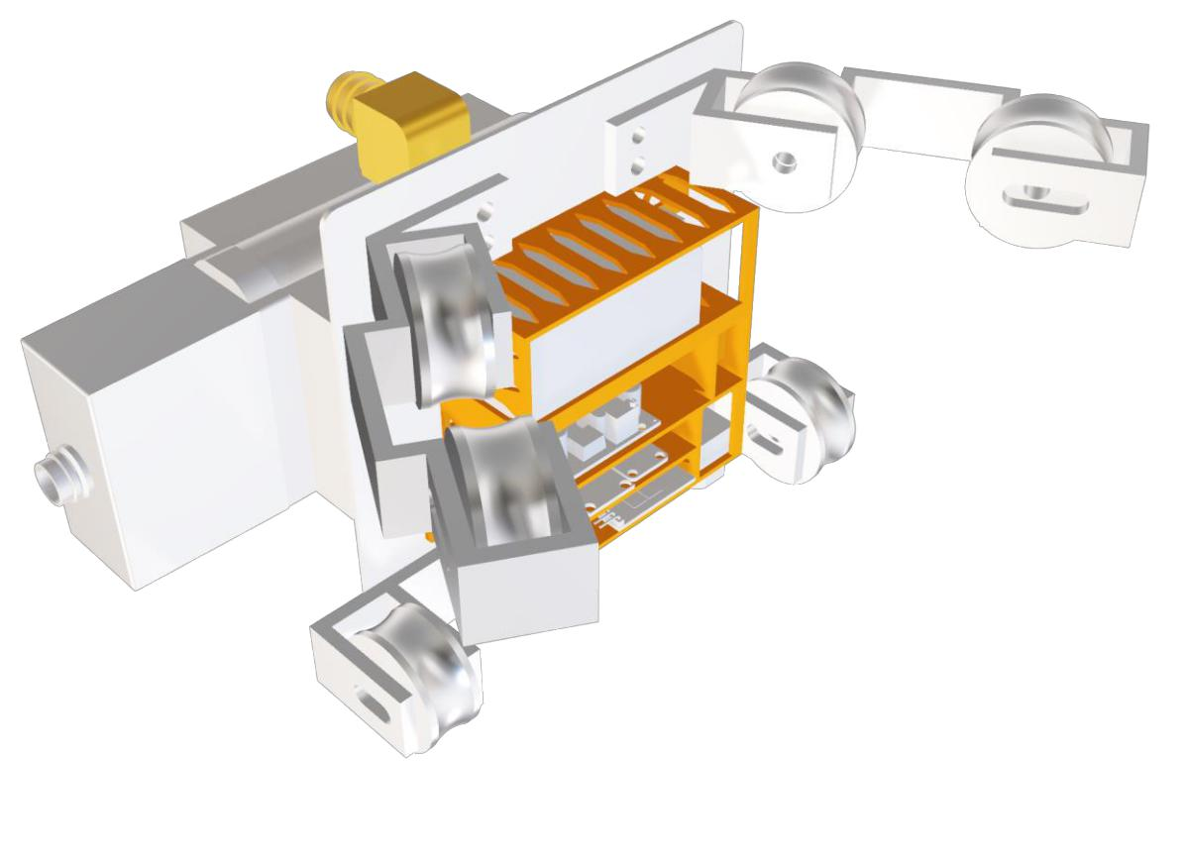

1

Contents

1. Rocket Hopper – Experimental Setup 3

2. Task Description 4

3. Evaluation criteria for the approval to the test campaign 5

4. Timeplan 6

2
1. Rocket Hopper – Experimental Setup
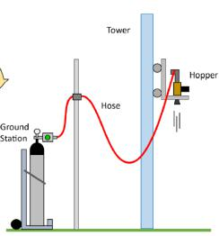

The Rocket Hopper is a cold propelled vehicle. It’s divided in two main parts, (1) the ground segment with the pressure supply and (2) the flight segment, which is attached to a vertical traverse and limits the movement (altitude) to 1 Degree of Freedom. A maximum flight altitude of 5m can be achieved.

Ground Segment

High pressure Nitrogen (300bara) coming from the gas bottle is fed through a pressure reducer to provide 10bara to 12bara pressure to the flight segment. The ground segment is connected to the flight segment through an 8m long hose. The ground segment is equipped with a safety valve, that automatically opens when the pressure in the system exceeds a threshold. This is to

prevent damage to the system and hazardous situations to the operators. A drain valved (NO) is installed to depressurize the system in a controlled manner at the end of testing. The drain valve is remote controlled.
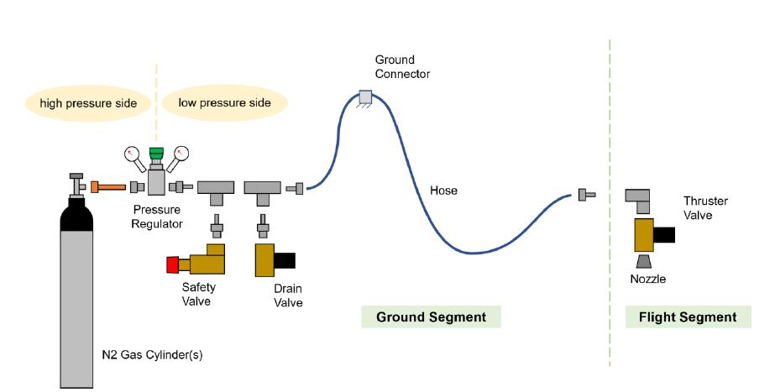

3
Flight Segment

The flight segment consists of the sled, which is attached to the traverse, the main valve, the nozzle, and the avionics.

Main Valve

The main valve is a remote-controlled proportional valve. The valve comes with an internal low level PID controller. It sets its downstream pressure by changing its flow coefficient. The user input is therefore the downstream pressure of choice. Pressure values between 1bara and 11bara can be selected. The maximum flow coefficient of the valve reads Kv=4.8. The opening response time is 60ms, the closing response time reads 80ms.

Nozzle

Directly downstream of the main valve follows the nozzle. In fact, the nozzle is a plug fitting, and the nozzle contour is manufactured into it. The nozzle is attached to the valve outlet port. Hence, it can be assumed that the downstream valve pressure corresponds to the inlet pressure of the nozzle. The throat diameter is 9mm. The maximum thrust that the valve together with the nozzle provides is 60N.

Avionics

A Teensy 4.1 is used for data acquisition and sending control inputs to the main valve. An IMU providing acceleration data and a LIDAR providing altitude data are mounted on the flight segment. In addition, the main valve measures its downstream pressure and sends it to the microcontroller.

2. Task Description

During the course, students are expected to synthesize a controller that is capable of controlling the altitude of the cold gas-powered Hopper. This breaks down to a Single Input Single Output (SISO) control problem, while the altitude of the Hopper is the controlled variable (SO), and the main valve downstream pressure is the control input (SI). The controller synthesized by the students will be tested for functionality in a simulation environment and subsequently deployed for flight experiments on the Hopper.

The tasks of this practical course are carried by teams of 3 students each and break down into

- Implementation of a simulation environment (digital twin) to simulate the Hopper dynamics and test the controller in a safe environment

- Synthesize the control law in the simulation environment

- Evaluate the controller against the provided criteria (follows below in this document)

- Documentation of the aforementioned work packages in a paper-style report to receive approval for the test campaign

- Deploying and testing the control algorithm on the Hopper

- Comparing and analysing the control performance in the simulation environment vs. reality and complementing the paper-style report with the findings

- 20 min Presentation of the project

4
3. Evaluation criteria for the approval to the test campaign

To receive the approval to the test campaign, the following criteria must be demonstrated in Report Part 1:

- The physical modelling has to be comprehensible; reasonable assumptions have to be made to reduce the system to a degree that allows for comparability between the simulated system and the real system.

- The numerical integrator must adequately simulate the mathematical model; it must ensure that the numerical integrator does not exhibit unstable behaviour, and the numerical integration error is small.

- The modelling of the fluid simulation must be verified through a comparison model (ground truth) in Ecosim.

- The controller must be capable of real-time control of the system.

- The controller must be able to stabilize the system in the reference scenario; stability must be proven either mathematically (optimally) or through suitable simulations.

- If a steady-state value is not attained (e.g., instead, there is a continuous oscillation/limit cycle), it must be justifiable that this will not pose a risk to the real system.

- The controller has to be robust enough to stabilize the system despite minor modelling inaccuracies. This must be demonstrated either mathematically (optimally) or through suitable simulations.

- The controller should be capable of reliably regulating the system throughout the desired operating range.

The order of the criteria, in which they are listed is no indication to their relevance.

5
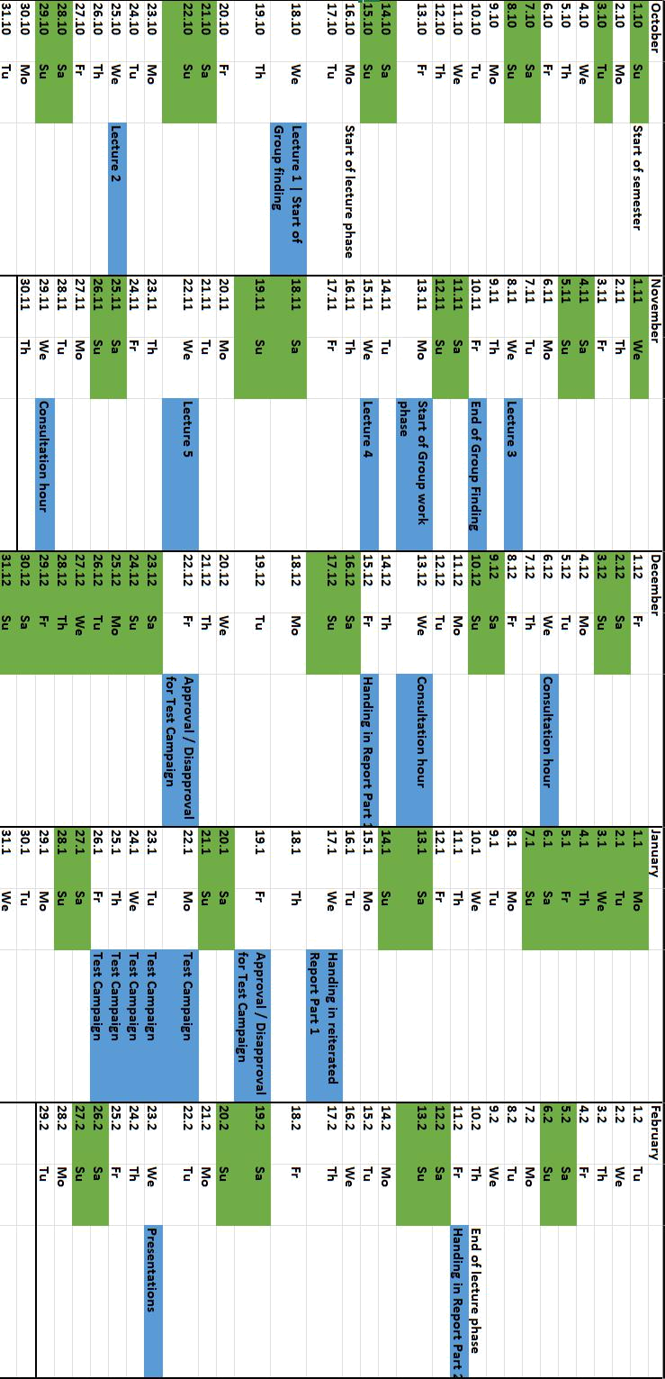
4. Timeplan

6

